Order Of Service

Singing: Psalm 33—CW page 79

Reading: Psalm 107:1-9

Opening Hymn: CW 200

Reading: Acts 25:1-12

Request Hymn: CW Supplement 716

Reading: Matthew 11:7-15

Sermon Hymn: CW 363

Sermon Text: Mark 10:28-31

Now And In Eternity

Prayer

The Apostles’ Creed, TLH page 12

Holy Communion

The Lord's Prayer

The Blessing

Closing Hymn: CW 496

* * * * * * * * * * *

Koinonia Hour

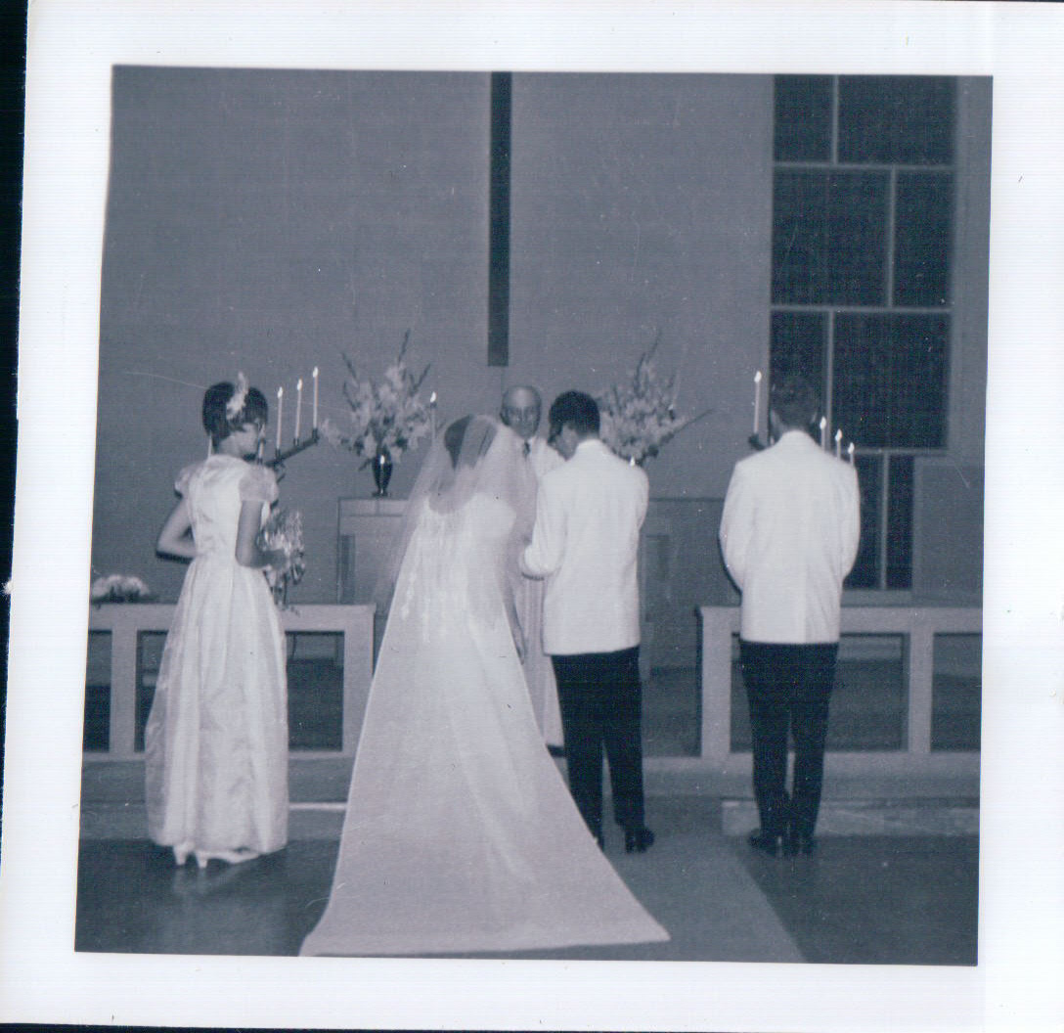

Husband And Wife

Water
Of
Life

3 November 2019

W A T E R O F L I F E

Independent Christian Church—Conservative Lutheran Doctrine

Worship Service: 9:30 a.m. Bible Study: 10:45 a.m.

Larry Cooper, Pastor E-Mail address:
111 N. Ridge Road lcooper@wateroflife.cc
Coon Valley, WI 54623 Web Site:
www.wateroflife.cc

* * * * * * * * * * * * * * * * * * * * * * * * * * *

Sermon Text: Mark 10:28-31

Now And In Eternity

* * * * * * * * * * * * * * * * * * * * * * * * * * *

Mark 10:28 Then Peter began to say unto him, Lo, we have left all, and have followed thee.
:29 And Jesus answered and said, Verily I say unto you, There is no man that hath left house, or brethren, or sisters, or father, or mother, or wife, or children, or lands, for my sake, and the gospel's,
:30 But he shall receive an hundredfold now in this time, houses, and brethren, and sisters, and mothers, and children, and lands, with persecutions; and in the world to come eternal life.
:31 But many that are first shall be last; and the last first.

Revelation 22

1 And he shewed me a pure river of water of life, clear as crystal, proceeding out of the throne of God and of the Lamb.
2 In the midst of the street of it, and on either side of the river, was there the tree of life, which bare twelve manner of fruits, and yielded her fruit every month: and the leaves of the tree were for the healing of the nations.
3 And there shall be no more curse: but the throne of God and of the Lamb shall be in it; and his servants shall serve him:
4 And they shall see his face; and his name shall be in their foreheads.
5 And there shall be no night there; and they need no candle, neither light of the sun; for the Lord God giveth them light: and they shall reign for ever and ever.

16 I Jesus have sent mine angel to testify unto you these things in the churches. I am the root and the offspring of David, and the bright and morning star.
17 And the Spirit and the bride say, Come. And let him that heareth say, Come. And let him that is athirst come. And whosoever will, let him take the water of life freely.
18 For I testify unto every man that heareth the words of the prophecy of this book, If any man shall add unto these things, God shall add unto him the plagues that are written in this book:
19 And if any man shall take away from the words of the book of this prophecy, God shall take away his part out of the book of life, and out of the holy city, and from the things which are written in this book.
20 He which testifieth these things saith, Surely I come quickly. Amen. Even so, come, Lord Jesus.
21 The grace of our Lord Jesus Christ be with you all. Amen.

